

Example
GIC Calculation Example

Randy Horton, Ph.D., P.E.
Sr. Project Manager
Electric Power Research Institute, Inc.
Mar 2012

Example Case Description
The example system represents a hypothetical 20 bus EHV network consisting of 500kV and 345kV lines and transformers. Fig. 1 shows a single-line diagram of the network. The network includes single transmission lines as well as some that occupy the same transmission corridor. The substations feature both conventional transformers and autotransformers. Also included are series and neutral connected GIC blocking devices.
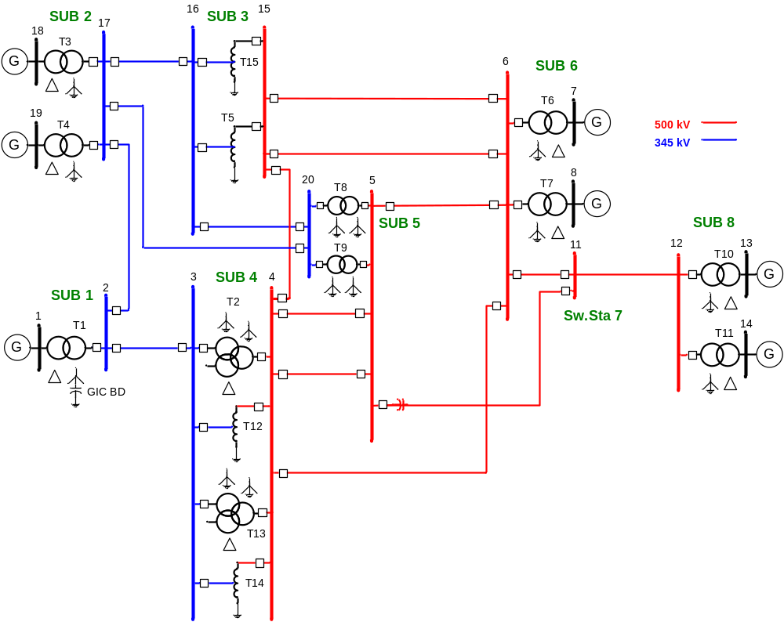
Figure 1. One Line Diagram of Example System

Data for the system described in Figure 1 is provided in Tables 1-3.

Table 1. Substation Location and Grid Resistance
Name | Latitude | Longitude | Grounding Resistance (Ohm)
Sub 1 | 33.613499 | -87.373673 | 0.2
Sub 2 | 34.310437 | -86.365765 | 0.2
Sub 3 | 33.955058 | -84.679354 | 0.2
Sub 4 | 33.547885 | -86.074605 | 1.0
Sub 5 | 32.705087 | -84.663397 | 0.1
Sub 6 | 33.377327 | -82.618777 | 0.1
Sub 7 | 34.252248 | -82.836301 | N/A
Sub 8 | 34.195574 | -81.098002 | 0.1

Table 2. Transmission Line Data
Line | From Bus | To Bus | Voltage  (kV-LL) | Length (miles) | Resistance (ohm/phase)
1 | 2 | 3 | 345 | 77.18 | 3.512
2 | 2 | 17 | 345 | 77.47 | 3.525
3 | 15 | 4 | 500 | 87.51 | 1.986
4 | 17 | 16 | 345 | 102.54 | 4.665
5 | 4 | 5 | 500 | 103.31 | 2.345
6 | 4 | 5 | 500 | 103.31 | 2.345
7 | 5 | 6 | 500 | 131.05 | 2.975
8 | 5 | 11 | 500 | 154.57 | 3.509
9 | 6 | 11 | 500 | 63.59 | 1.444
10 | 4 | 6 | 500 | 205.57 | 4.666
11 | 15 | 6 | 500 | 128.81 | 2.924
12 | 15 | 6 | 500 | 128.81 | 2.924
13 | 11 | 12 | 500 | 102.39 | 2.324
14 | 16 | 20 | 345 | 88.98 | 4.049
15 | 17 | 20 | 345 | 152.53 | 6.940

Table 3. Transformer Data
Name | Type | Resistance W1  (Ohms/phase) | Bus No. | Resistance W2  (Ohms/phase) | Bus No.
T1 | GSU w/ GIC BD | 0.1 | 2 | N/A | 1
T2 | GY-GY-D | 0.2 | 4 | 0.1 | 3
T3 | GSU | 0.1 | 17 | N/A | 18
T4 | GSU | 0.1 | 17 | N/A | 19
T5 | Auto | 0.04 | 16 | 0.06 | 15
T6 | GSU | 0.15 | 6 | N/A | 7
T7 | GSU | 0.15 | 6 | N/A | 8
T8 | GY-GY | 0.04 | 5 | 0.06 | 20
T9 | GY-GY | 0.04 | 5 | 0.06 | 20
T10 | GSU | 0.1 | 12 | N/A | 13
T11 | GSU | 0.1 | 12 | N/A | 14
T12 | Auto | 0.04 | 4 | 0.06 | 3
T13 | GY-GY-D | 0.2 | 4 | 0.1 | 3
T14 | Auto | 0.04 | 4 | 0.06 | 3
T15 | Auto | 0.04 | 15 | 0.06 | 16

OpenDSS Script for Example System
The following script can be used to model the example system in OpenDSS with an Eastward geoelectric field of 1 V/km.
Clear
New circuit.GICtest
!GIC Line Data
New GICLine.1-Bus2-Bus3 bus1=2 bus2=3 R=3.512 Lat1=33.613499 Lon1=-87.373673 Lat2=33.547885 Lon2=-86.074605 EE=1.00 EN=0.00
New GICLine.2-Bus2-Bus17 bus1=2 bus2=17 R=3.525 Lat1=33.613499 Lon1=-87.373673 Lat2=34.310437 Lon2=-86.365765 EE=1.00 EN=0.00
New GICLine.3-Bus15-Bus4 bus1=15 bus2=4 R=1.986 Lat1=33.955058 Lon1=-84.679354 Lat2=33.547885 Lon2=-86.074605 EE=1.00 EN=0.00
New GICLine.4-Bus17-Bus16 bus1=17 bus2=16 R=4.665 Lat1=34.310437 Lon1=-86.365765 Lat2=33.955058 Lon2=-84.679354 EE=1.00 EN=0.00
New GICLine.5-Bus4-Bus5 bus1=4 bus2=5 R=2.345 Lat1=33.547885 Lon1=-86.074605 Lat2=32.705087 Lon2=-84.663397 EE=1.00 EN=0.00
New GICLine.6-Bus4-Bus5 bus1=4 bus2=5 R=2.345 Lat1=33.547885 Lon1=-86.074605 Lat2=32.705087 Lon2=-84.663397 EE=1.00 EN=0.00
New GICLine.7-Bus5-Bus6 bus1=5 bus2=6 R=2.975 Lat1=32.705087 Lon1=-84.663397 Lat2=33.377327 Lon2=-82.618777 EE=1.00 EN=0.00
New GICLine.8-Bus5-Bus11 bus1=5 bus2=11 C=32.0 R=3.509 Lat1=32.705087 Lon1=-84.663397 Lat2=34.252248 Lon2=-82.836301 EE=1.00 EN=0.00
New GICLine.9-Bus6-Bus11 bus1=6 bus2=11 R=1.444 Lat1=33.377327 Lon1=-82.618777 Lat2=34.252248 Lon2=-82.836301 EE=1.00 EN=0.00
New GICLine.10-Bus4-Bus6 bus1=4 bus2=6 R=4.666 Lat1=33.547885 Lon1=-86.074605 Lat2=33.377327 Lon2=-82.618777 EE=1.00 EN=0.00
New GICLine.11-Bus15-Bus6 bus1=15 bus2=6 R=2.924 Lat1=33.955058 Lon1=-84.679354 Lat2=33.377327 Lon2=-82.618777 EE=1.00 EN=0.00
New GICLine.12-Bus15-Bus6 bus1=15 bus2=6 R=2.924 Lat1=33.955058 Lon1=-84.679354 Lat2=33.377327 Lon2=-82.618777 EE=1.00 EN=0.00
New GICLine.13-Bus11-Bus12 bus1=11 bus2=12 R=2.324 Lat1=34.252248 Lon1=-82.836301 Lat2=34.195574 Lon2=-81.098002 EE=1.00 EN=0.00
New GICLine.14-Bus16-Bus20 bus1=16 bus2=20 R=4.049 Lat1=33.955058 Lon1=-84.679354 Lat2=32.705087 Lon2=-84.663397 EE=1.00 EN=0.00
New GICLine.15-Bus17-Bus20 bus1=17 bus2=20 R=6.940 Lat1=34.310437 Lon1=-86.365765 Lat2=32.705087 Lon2=-84.663397 EE=1.00 EN=0.00
!GIC Transformer Data
New GICTransformer.T1 busH=2 busNH=2.4.4.4 R1=0.1 type=GSU
New GICTransformer.T2 busH=4 busNH=4.4.4.4 busX=3 busNX=4.4.4.4 R1=0.2 R2=0.1 type=YY
New GICTransformer.T3 busH=17 busNH=17.4.4.4 R1=0.1 type=GSU
New GICTransformer.T4 busH=17 busNH=17.4.4.4 R1=0.1 type=GSU
New GICTransformer.T5 busH=15 busX=16 busNX=15.4.4.4 R1=0.04 R2=0.06 type=Auto
New GICTransformer.T6 busH=6 busNH=6.4.4.4 R1=0.15 type=GSU
New GICTransformer.T7 busH=6 busNH=6.4.4.4 R1=0.15 type=GSU
New GICTransformer.T8 busH=5 busNH=5.4.4.4 busX=20 busNX=5.4.4.4 R1=0.04 R2=0.06 type=YY
New GICTransformer.T9 busH=5 busNH=5.4.4.4 busX=20 busNX=5.4.4.4 R1=0.04 R2=0.06 type=YY
New GICTransformer.T10 busH=12 busNH=12.4.4.4 R1=0.10 type=GSU
New GICTransformer.T11 busH=12 busNH=12.4.4.4 R1=0.10 type=GSU
New GICTransformer.T12 busH=4 busX=3 busNX=4.4.4.4 R1=0.04 R2=0.06 type=Auto
New GICTransformer.T13 busH=4 busNH=4.4.4.4 busX=3 busNX=4.4.4.4 R1=0.2 R2=0.1 type=YY
New GICTransformer.T14 busH=4 busX=3 busNX=4.4.4.4 R1=0.04 R2=0.06 type=Auto
New GICTransformer.T15 busH=15 busX=16 busNX=15.4.4.4 R1=0.04 R2=0.06 type=Auto
New Capacitor.T1 bus1=2.4 bus2=2.5 phases=1 cuf=10

!Substation Ground Grid Data
New Reactor.SUB1gnd phases=1 bus1=2.5 R=0.200 X=0
New Reactor.SUB2gnd phases=1 bus1=17.4 R=0.200 X=0
New Reactor.SUB3gnd phases=1 bus1=15.4 R=0.200 X=0
New Reactor.SUB4gnd phases=1 bus1=4.4 R=1.0 X=0
New Reactor.SUB5gnd phases=1 bus1=5.4 R=0.100 X=0
New Reactor.SUB6gnd phases=1 bus1=6.4 R=0.100 X=0
New Reactor.SUB8gnd phases=1 bus1=12.4 R=0.100 X=0
!Perform analysis
Set frequency=0.1
Calcv
Solve
!Load file with bus coordinates, used for plotting
LatLongCoords LatLonFile.csv
Show Current Elements
plot circuit Current Max=70 dots=y labels=y subs=n C1=$00FF0000

